ACE GEAR TENNIS RACKET WEBSITE

1. Project Overview

Objective
. This website bridges the knowledge gap by simplifying technical information into accessible guidance.
The ACEGEAR Tennis Racket Website is a modern, user-centered digital platform designed to help tennis players identify and purchase the most suitable racket based on skill level, playing style, and budget. The platform combines e-commerce functionality with educational resources to support informed decision-making.

Purpose and Rationale
Choosing the right tennis racket significantly affects performance, injury prevention, and skill development. According to the International Tennis Federation (ITF), racket characteristics such as weight, balance, and string pattern directly influence power, control, and player comfort.

2. Goals of the Website
- Provide accurate, research-based information about tennis rackets.
- Enable easy comparison of products through structured data.
- Deliver an intuitive and engaging user experience across devices.
- Promote accessibility of tennis equipment to a broader, digitally active audience.
- Support users in making data-driven purchasing decisions.

3. Target Audience Analysis

Audience
- Age group:10 –65+ years user
- Skill level: Beginner to Professional users.

User Characteristics
- Digitally literate and comfortable with online shopping
- Interested in sports performance and improvement
- Value convenience, clarity, and visual interaction

User Needs (Based on Research)
Sports usability studies show that users prefer:
- Clear product categorization
- Visual comparisons
- Simple explanations of technical specifications
- Mobile-friendly design

4. Website Type
A hybrid platform combining:
- E-commerce functionality (product browsing and comparison)
- Informational content (guides and tutorials)
This dual approach aligns with findings from Nielsen Norman Group, which emphasize that users engage more with platforms that both educate and facilitate action.

5. Information Architecture
The website is structured to follow a logical, user-driven navigation path, ensuring clarity and ease of use.

Main Sections:
- Home
- Rackets
- Compare
- Guide
- Feedback/Contact

6. Linear Storyboard
The original storyboard has been redesigned into a . This website bridges the knowledge gap by simplifying technical information into accessible guidance.
to improve clarity and engagement.

Step 1: Landing (Home Page)
- User arrives on the homepage
- Sees brand introduction and featured rackets
- Notices promotions and highlights
Purpose: Capture attention and establish credibility

Step 2: Explore Products (Rackets Section)
- User navigates to “Rackets”
- Selects category:
  - Beginner
  - Intermediate
  - Professional
Each product displays:
- Image
- Name
- Price
- Specifications (weight, grip size, balance)
Expert Insight:
According to sports equipment research, racket weight and balance are key determinants of control and power, making this information essential at this stage.

Step 3: Evaluate Options (Compare Section)
- User selects multiple rackets
- Views side-by-side comparison
Comparison includes:
- Weight
- Power
- Control
- Material
Purpose: Reduce decision fatigue through visual comparison
Research Support:
Consumer behavior studies show that comparison tools increase purchase confidence and reduce abandonment rates.

Step 4: Learn & Understand (Guide Section)
- User accesses educational content
Topics include:
- How to choose a racket
- Grip size explanation
- Weight and balance guide
- Beginner tips
Expert Reference:
Coaching professionals emphasize that proper grip size prevents injuries such as tennis elbow, reinforcing the importance of this section.

Step 5: Decision & Action
- User returns to product page with improved understanding
- Makes a selection

Step 6: Feedback/Contact & Support
- User accesses contact page
- Submits inquiry via form
Fields include:
- Email
- Message
Purpose: Provide support and build trust
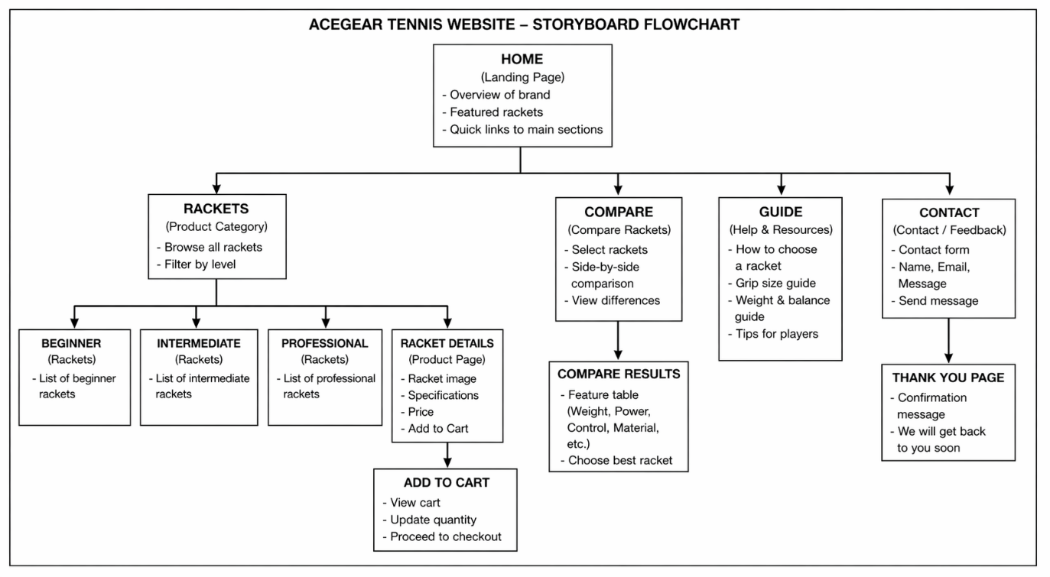

7. Design Considerations

User Experience (UX)
- Simple navigation structure
- Mobile-first responsive design
- Clear call-to-action buttons

Visual Design
- Clean, modern layout
- High-quality product images
- Consistent branding

Accessibility
- Readable fonts
- Logical content hierarchy
- Easy-to-understand terminology

8. Technical Implementation

Technologies Used
- HTML5 – Structure and content
- CSS3 – Styling and layout
- Bootstrap – Responsive design framework
- JavaScript – Interactivity and dynamic features

Tools & Resources
- Visual Studio Code (development environment)
- GitHub (version control)
- GitHub Pages (deployment)

9. Conclusion
The ACEGEAR Tennis Racket Website is designed as a user-focused, research-driven platform that integrates product discovery, comparison, and education into a seamless experience.
By restructuring the storyboard into a linear journey, the website now:
- Guides users step-by-step
- Reduces confusion
- Improves engagement
- Supports informed decision-making
This approach ensures that users are not only browsing products but are also empowered with knowledge, ultimately leading to better choices and a more satisfying experience.

10. Final Impact Statement
This project demonstrates how combining technology, design, and expert-backed information can transform a simple e-commerce site into a comprehensive decision-support system for modern consumers.
HIGH-FIDELITY WIREFRAMES
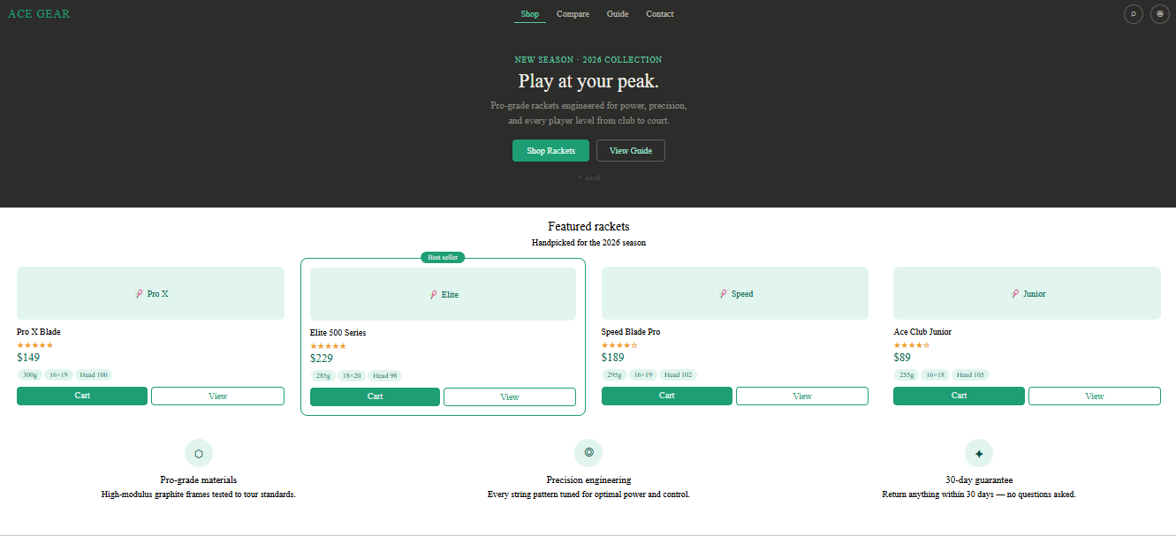
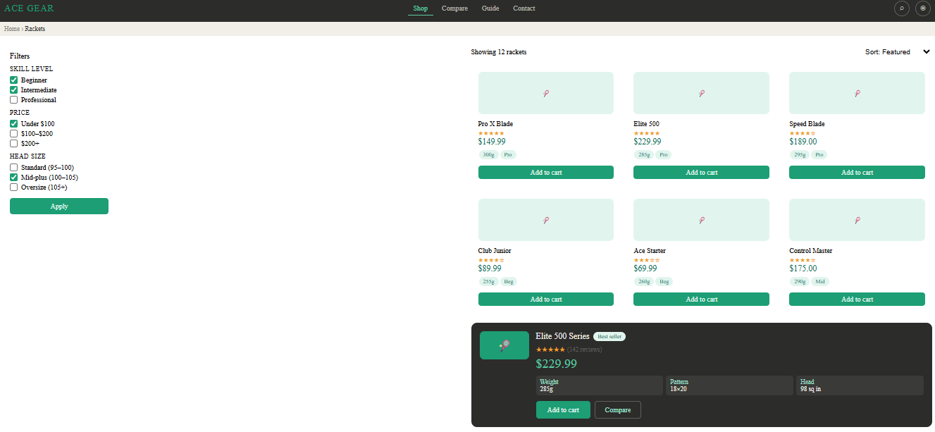

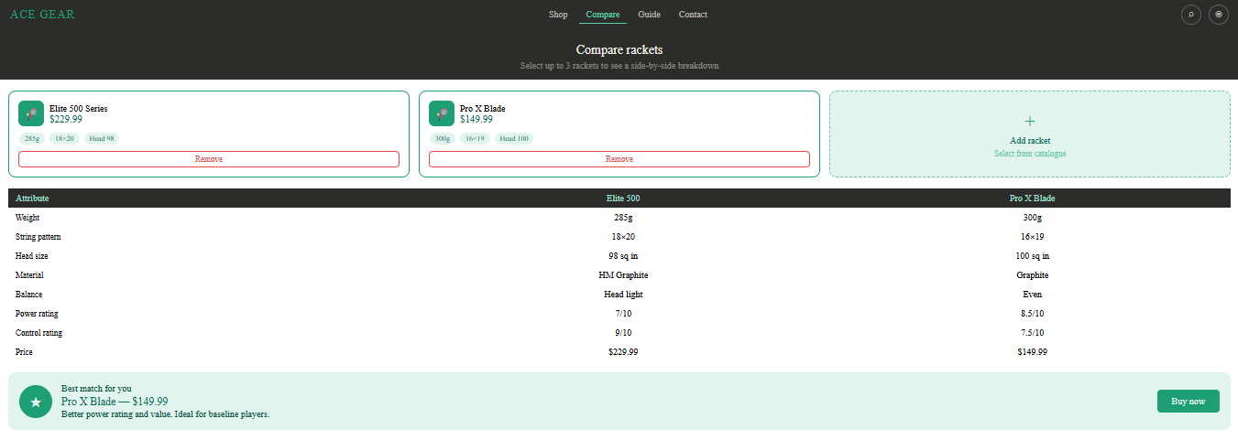

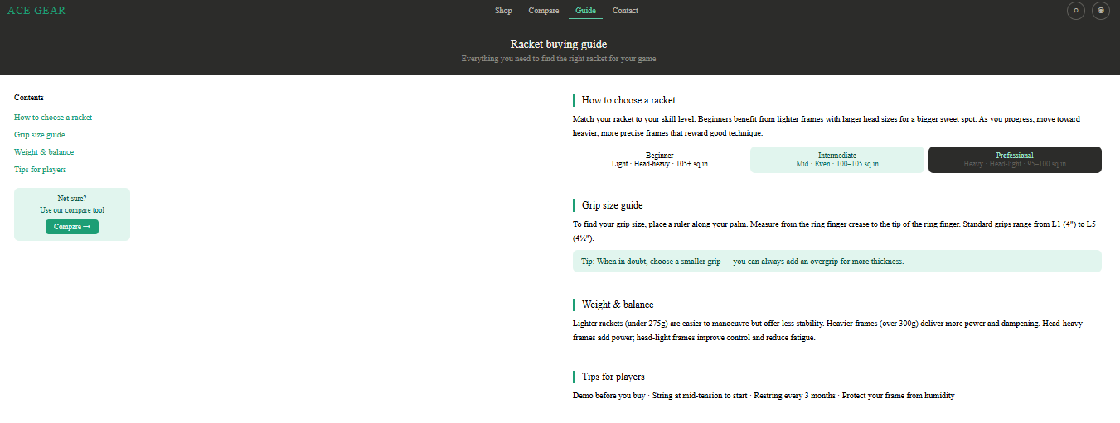

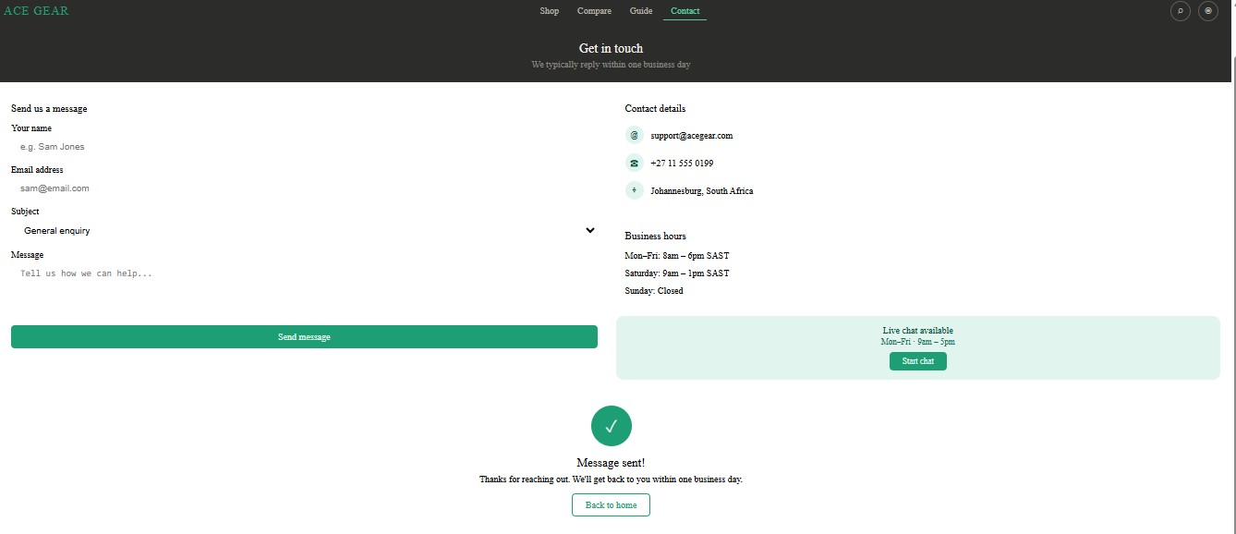
LOW FIDELITY WIREFRAMES
